***Lab Project Report***

1.About the Project:-

Introduction: -

This lab project focuses on creating a Tic-Tac-Toe game using Python and Tkinter. The project aims to evaluate the students' understanding of Python programming, specifically in the context of GUI development using Tkinter. The game provides an opportunity for students to apply their knowledge and skills in a practical project and showcases their proficiency in Python programming.

Project Members:-

* Guda Sri Venkata Prabhas
* Moram Vikram Aditya
* Mohammed Arafath

Objective:

The objectives of the project are as follows:

- Evaluate the students' learning of Python programming, including the concepts and techniques covered in their coursework and lab sessions.

- Familiarize the students with the process of working on a project, including planning, implementation, and testing, to prepare them for future project work in subsequent years of their B.Tech program.

- Encourage the students to tackle real-world problems and provide feasible solutions by developing a functional Tic-Tac-Toe game using Python and Tkinter.

- Promote teamwork and collaboration among the students by fostering idea exchange, discussions, knowledge transfer, and presentations, simulating a professional IT work culture.

2. Comparative Study:-

As part of the project, a comparative study was conducted to analyze different aspects related to the Tic-Tac-Toe game implementation. The study encompassed the following key areas:

a. Similar or Closely Related Projects:

- Several existing Tic-Tac-Toe game projects were researched and analyzed to gain insights into their features, design choices, and user experiences.

- The team examined different implementations, both in terms of functionality and visual design, to identify common patterns and potential areas for improvement.

b. Software and Libraries Comparison:

- A thorough comparison of various software options, libraries, and algorithms relevant to GUI development with Python and Tkinter was conducted.

- The team evaluated different frameworks and tools available for building the graphical components of the Tic-Tac-Toe game.

- Consideration was given to factors such as ease of use, documentation availability, community support, and compatibility with the project requirements.

c. Algorithm Evaluation:-

- Different algorithms used in Tic-Tac-Toe game implementations were examined and compared in terms of their efficiency, complexity, and suitability for the project.

- The team analyzed algorithmic approaches for move processing, win detection, and tie conditions to determine the most appropriate solution.

Based on the comparative study, the team made informed decisions regarding the design and implementation choices for the Tic-Tac-Toe game, ensuring the project's alignment with best practices and optimal utilization of available resources.

3. Architectural Diagram:-The architectural diagram below illustrates the flow of data across the modules and components of the Tic-Tac-Toe game: 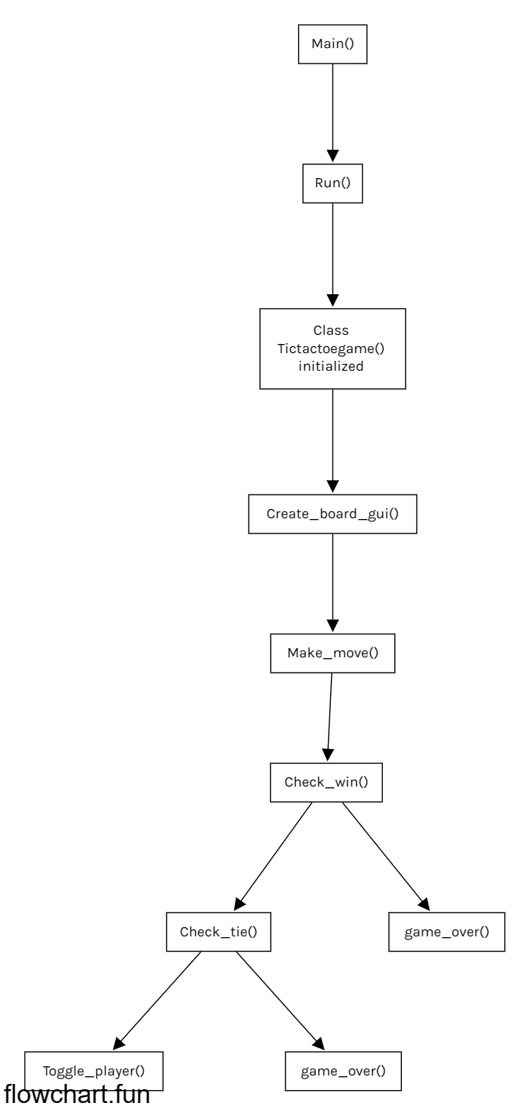

4. Testing the Project:-

To ensure the reliability and functionality of the Tic-Tac-Toe game, the following testing approach was adopted:

a. Test cases:

- A rigorous set of test cases was designed to evaluate the sensitivity and accuracy of the game's functionalities.

- The test cases covered various scenarios, including valid moves, invalid moves, winning conditions, tie conditions, and user interactions.

b. Evaluation parameters:

- The parameters for evaluating and testing the Tic-Tac-Toe game included the correctness of move processing, detection of wins and ties, graphical display updates, and player switching.

- The game's performance in handling user inputs, responsiveness, and adherence to the game rules was also assessed.

5. Conclusion:-

The project resulted in the development of a functional Tic-Tac-Toe game using Python and Tkinter. The implementation achieved the following outcomes:

- The game provides an interactive graphical user interface that allows players to make moves and responds accordingly.

- The game accurately detects winning conditions and declares the winner.

- The game handles tie conditions correctly and provides appropriate feedback.

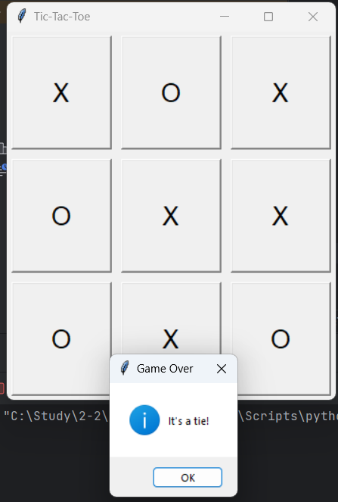

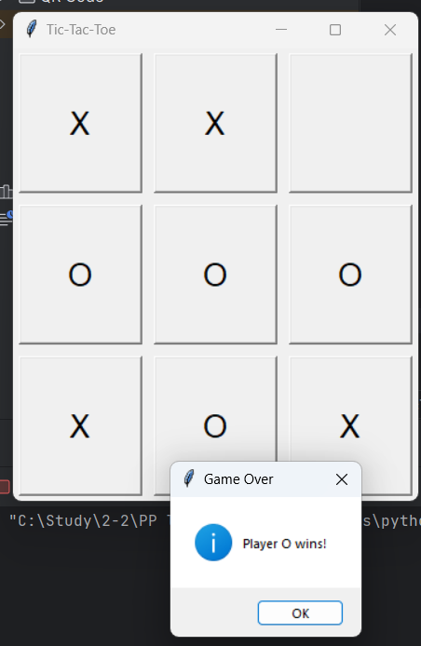 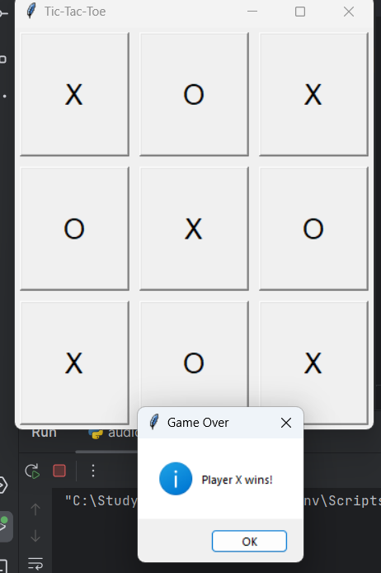

In conclusion, the project successfully demonstrates the students' proficiency in Python programming, specifically in GUI development using Tkinter. The Tic-Tac-Toe game fulfills its objectives by providing an engaging user experience and serving as an example of the students' ability to develop real-world applications.

6. Enhancements/Future Work:-

The Tic-Tac-Toe game project offers several potential areas for future enhancements and improvements. Some possible enhancements include:

- Implementing an AI opponent with different difficulty levels to enable single-player gameplay.

- Adding sound effects and animations to enhance the user experience.

- Implementing a multiplayer mode to allow players to compete against each other over a network.

- Enhancing the game's visual design and interface aesthetics.

- Integrating a high-score system to track players' performance and achievements.

These enhancements and future work opportunities provide avenues for the students to further develop and expand their skills in Python programming and GUI development.

7. References:-

During the completion of the project, the team referred to the following resources:

* <https://www.geeksforgeeks.org/python-gui-tkinter/>
* <https://www.w3schools.in/python/gui-programming>
* <https://medium.com/byte-tales/the-classic-tic-tac-toe-game-in-python>
* [Flowchart Fun — Fast, Free Online Flowchart Maker](https://flowchart.fun/)